INFO 646 Assignment 4

Wenyu He, Xujian Zhang, Xiang Liu, Aldercy Wang, Toni Spotts, Sherrise Parker

06/08/2018

### **1.1 Organizational Mission and Business Model**

**a) How does the proposed IS application enable us to achieve our organizational mission?**Based on the fierce competition of ecommerce company, the organizational mission of Best Buy is to focus on solving unmet needs and provide unique experiences to their targeted customers, so Best Buy cannot fully rely on outsourcing to design their products, that’s why product design system come into our mind, this system gave employees an opportunity to join with suppliers to design Best Buy-specialized products, the Best Buy brand with the goal to fill consumers’ preference will further increase the market share. We also developed order processing system to not only helped Best Buy to manage and process all its orders but also simplify consumer ordering process, this convenient process helps increase customer loyalty. Direct marketing and ecommerce system provide customers an options to either order online or order in store when they come into stores to experience our products, the in-store price is same with online price to increase our competency. We also have the budgeting system to monitor return on investment rate by comparing budgeting and value-added rates of new products, especially for the high tech products such as smart home devices. Lastly, office system will help Best Buy to control routine operations and report for any abnormal actions.

**b) How does the proposed IS application enable us to change our business model: consider each of the four-quadrants of the business model:**

**The Customer Value Proposition** – In order to cater to the growing interest in “smart home” technology, Best Buy is rolling out “Connected Home” sections at 400 of its 1050 stores, Best Buy also designed 850-square-foot areas in each store to give consumers an opportunity to experience over 100 products such as Philips Hue smart lighting, Nest programmable thermostats, or home surveillance cameras. Instead of normal electronic commodities, the relative complexity of home technologies left an opening for Best Buy, which need store associate to explain what it is, this is very difficult to do in an ecommerce business. In order to attracts customers, Best Buy also give extra training for these products as well as provide smart home category in their Black Friday promotion.(Wahba, 2014)

**The Firm’s Profit Model** – The value chain of Best Buy reflected in their services and latest products with All in One Place shopping experience, Impartial and Knowledgeable Advice, and Competitive Prices. The proposed online customer specification system will serve customers better by collecting customers’ preference and further increase customers’ shopping experience and satisfaction, it also helps Best Buy to update their product design in order to fill customers’ needs. The proposed supplier system allows Best Buy to effective manage the relationship with their suppliers and cut many intermediate suppliers and heavily save the cost from supplier to Best Buy and further help Best Buy to provide competitive prices with online competitors. The proposed customer relationship management system is highly important in Best Buy’s profit model in compete with online competitors because store associate could provide sincere and knowledgeable advice when they understand customers’ needs, this system helps Best Buy to effectively manage its relationship with its customers and further increase customers’ loyalty.

**Critical Business Processes** – we designed relative IS system from inventory to sales in order to maximize the value added goal. In the beginning, we designed product database/inventory management system in order to effectively and efficiently manage its product database and inventory, this system not only helps store analyst to keep track of customer preference, but also helped customers to see any out-of-order items conveniently. We also designed mobile phone sales system to satisfy Millennials purchase custom, our mobile phone sales system is very friendly in order to simplify and improve research, discovery, and checkout processes. All real-time data will be analyzed in Advertising and Promotion management system and help manager to generate customer promotions strategy to explore new customers and increase loyalty of existing customers.

**Critical Resources for the business** – the new IS-oriented business processes, new smart home product line, and impartial advice require amount of knowledgeable employees, so Best Buy need to improve training program by open Best Buy University to reduce cycle time for employee training. We also designed Learning Management system for Best Buy to support behavioral improvements of employees, it will list high potential training category to further add values for the future development of the company. In addition, Best Buy could consider to add a business intelligence team focus on Internet of Things because this product line is very complex in contrary with normal electronic products. Instead of collecting and analyzing data of customers’ behavior, team member need knowledge in informatics algorithm in order to fully understand the smart product line. Cloud

**c) How are elements of the change related? For example, how does adding new technology or updating IS in the critical resources quadrant enable us to change Critical Business Processes, which allows us to change the Customer Value Proposition and/or The Firm’s Profit Model in <specific> ways (that you will explain)?**

As the deployment of IS system, Best Buy need an advanced technology to achieve cost-saving and revenue growth in the upcoming future. Since 2015, enterprises’ adoption of IaaS of cloud computing as the primary environment for workloads increase 47%, especially for the innovative enterprise which need reinvent themselves as unstoppable forces. Although migrating workload to cloud is a huge expenditure, however, businesses choose cloud computing over On-Premises solutions and as a DevOps Development Platform for the benefits of flexibility, efficiency and the strategic values:

Flexibility:

1. Cloud computing could support fluctuating workloads and provide public, private, or hybrid storage offering for users to fill different security requirements
2. as-a-service option such as software as a service(SaaS), platform as a service(PaaS), and infrastructure as a service(IaaS) help organization to determine the level of control

Efficiency:

1. Deployment of cloud developed application can get to market quickly and can be easily accessed by any authorized device
2. Cloud computing save amount of organizational cost of utilizing IS systems by using remote resources instead of physical equipment
3. Data is also backup in real-time in case of any hardware failures that result in data loss

Strategic Values:

1. Cloud based application is updating the most up-to-date technology automatically
2. Cloud also offer worldwide access for teams to collaborate from widespread locations so that organizations can move more nimbly to manage IT infrastructures

Overall, technology and IS system is always the best combination for Best Buy to not only save costs and time but also increase the employee’ efficiency to understand the customers’ purchasing behaviors and will finally increase customer value propositions. (Columbus, 2016; Linthicum, 2016)

### **1.2 Value Chain and Value Network Changes (15%)**

In the retail industry procurement is an essential and vital component that encompasses various core business functions, and it is an integral part of Best Buy’s corporate strategy that enables them to define and identify its organizational brand, market placement, core competencies, and management issues. Best Buy’s procurement strategy focuses on acquiring goods and services that is vital to its success, and these business processes consist of “selecting vendors, establishing payment terms, strategic vetting, selection, the negotiation of contracts and actual purchasing of goods,” states (Lim, 2018).

Integrating a supplier relationship management (SRM) IS application across Best Buy’s value chain will maximize the interrelated activities for the following cross-functional groups: procurement, finance, marketing, and distribution by streamlining the flow of data to increase visibility across the supply chain and improve departmental business processes and workflows. Furthermore, to effectively and efficiently manage Best Buy’s supply chain the upstream and downstream processes of these cross-functional groups need to be integrated to enable each of the functional groups, which contain diverse levels of expertise to adapt rapidly in a retail landscape that is evolving dramatically.

The primary responsibilities of procurement fall between two categories that consist of strategic sourcing & vendor management, and procurement operations to source and purchase items needed, and supply Best Buy with tools, resources and services at their physical locations, distribution centers, offices, and effectively manage its revolving inventory (Best Buy Canada, 2018). Thus, a scalable SRM solution will aid Best Buy with “determining the supply categories that are important and creating the strategies that manage these items in an intelligent fashion,” according to (Webb, 2017), and provide a threefold process for:

* Supplier segmentation: Map suppliers against profitability and risk exposure.
* Supplier strategy development: Distribute internal resources and plans to meet business needs.
* Supplier strategy execution.

Therefore, enabling Best Buy to form strategic alliances that are mutually beneficial with critical suppliers, and assist the organization with effectively managing its supplier lifecycles. Also, an SRM solution would dynamically synchronize the upstream and downstream relationships in Best Buy’s supply chain management to create an “inter-organizational competitive advantage for both the retailer and the manufacturers, “states (Hogan, 2017). Moreover, by enlisting the help of its key suppliers would empower Best Buy with the ability to streamline their supply processes and create a supply chain that is reactive and responsive to consumer demand (Spiegel, 2011).

According to IBM (2005), an effective SRM application would allow Best Buy to streamline communications with their key suppliers to enable cost-effective and strategic supply-related decisions that are executed based on the consolidated real-time information. IBM (2005) states, an investment in an SRM solution would empower Best Buy with the ability to design a flexible and responsive supply chain that would afford the following benefits:

* Increase its ability to dynamically sense and respond to changes within and outside their organization.
* Provide staff and suppliers with real-time, around-the-clock visibility into supply-related information across and beyond its organization (including data on supplier performance and competitive pricing)
* Leverage real-time collaboration capabilities to support the creation of innovative, quality products and services while shortening cycle times and supply-related costs.
* Achieve faster time-to-value and higher levels of productivity through automated, online processes (such as for RFP and RFQ cycles, order approvals and supplier acknowledgments and responses)
* Consolidate demand across multiple business units to optimize profit margins.

A strategically implemented SRM solution at Best Buy can yield the following four competitive advantages according to (Hogan, 2017):

**Accelerated time-to-market:** Supplier relationship management enhances communication between buyers and suppliers. SRM solutions are designed to enable a “talk less, deliver more” approach. For example, integrated procurement platforms such as the Ariba Supplier Network connects nearly “2 million suppliers and 400 buyers globally” to digitize and accelerate transactions.

**Improved spend control:** The Chartered Institute of Purchasing and Supply states, “60% of corporate spend is uncontrolled.” An effective SRM solution would centralize procurement and avoid fragmented sourcing processes that often result in higher spending. In addition, an SRM would enable Best Buy to improve visibility by pooling the purchasing habits of every department, thereby integrating all procurement data will allow Best Buy to adequately analyze its corporate spend for smarter decision making and control. Furthermore, prior to buyers communicating their needs with their suppliers, they can proactively identify all their needs to eliminate redundancy.

**Cost reduction**: Strategically cost reduction is a critical business aspect according to 74 percent of Chief Procurement Officers (CPOs), surveyed in 2016 in the Deloitte Global CPO Survey. Enhancing supplier relationships is a useful strategy for reducing supply chain costs. Employing an effective SRM solution, for example, buyers can gain insights into supplier performance, processes, and best practices that directly and indirectly affect its supply. Therefore, by understanding how suppliers work, buyers can avoid making untimely and inappropriate requests that can lead to delays, below average substitutions, or worse, denial of accommodation.

**Further innovation:** Enhancing the collaboration between suppliers and buyers can spark new innovations beneficial to all supply chain players. Therefore, arming all parties involved with a deeper understanding of how each player works, so that buyers and suppliers can work hand in hand to optimize product and service development to satisfy customer demands. Aside from this, Best Buy suppliers can also contribute to innovating its SRM platforms, for example employing a similar approach utilized by Wal-Mart and its suppliers that jointly optimized Wal-Mart’s proprietary Retail Link database system. In turn, Wal-Mart integrated value chains to achieve an inter-organizational competitive advantage for both the retailer and its suppliers.

To successfully develop and deploy a “world-class SRM” Best Buy will need to incorporate a procurement framework with seven key enablers to strategically position the SRM at the core of its corporate strategy states (PwC Accountants, 2013), and integrates the following best practices.

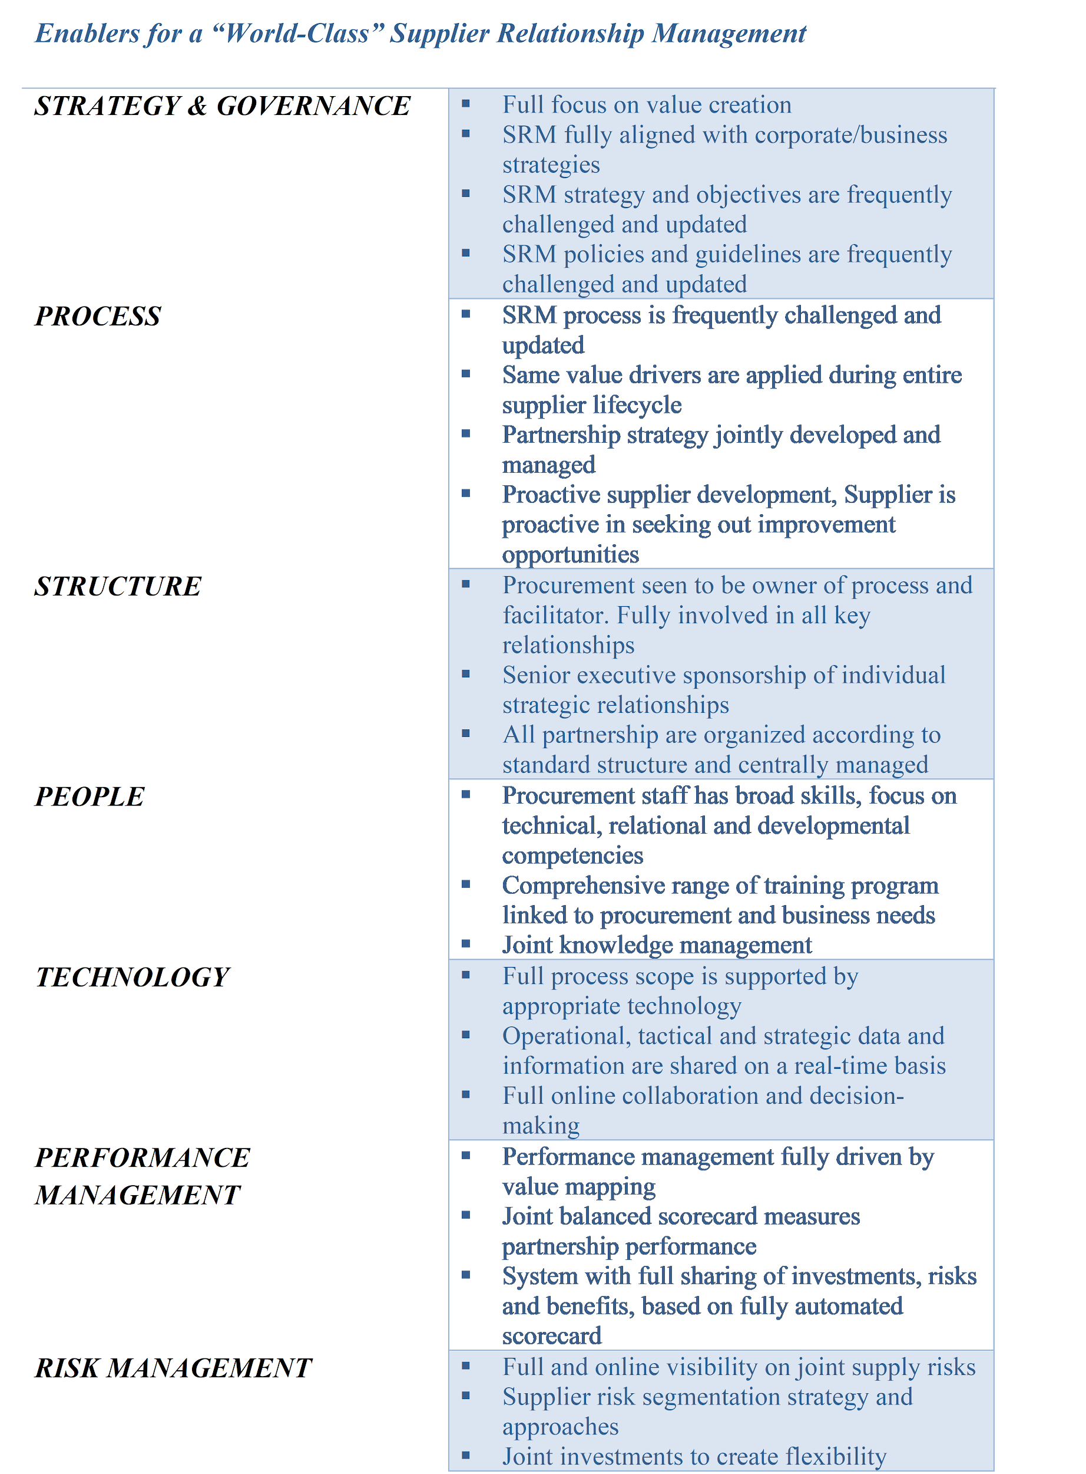

### 

### 

### **1.3 Information Service Delivery**

Suppliers have more bargaining power in the current business environment. It can be helpful to become a ‘customer of choice’ with key suppliers. This can yield advantages such as early access to in-demand products (Haag & DeWolf, 2017). One way Best Buy can improve relationships with key suppliers is by making sure their products are getting the appropriate marketing. For this, the sales and marketing team needs to know which brands and products are key and should be promoted more aggressively.

Analytics staff can combine market trends data with the company’s current sales and costs figures to determine which suppliers and products are likely to be the most profitable. The accounting team can provide information on which suppliers and products have produced the most profits. They need to compare sales and cost data. Those in charge of purchasing need to know which suppliers we want to purchase from and what products we want based on the information the analytics team has supplied.

Suppliers need to know what items are needed and where and when to ship them. For international suppliers, they also need to know which forms they are required to submit. Best Buy’s Global Import Compliance Department is responsible for keeping track of those forms (Best Buy, 2018) and need a way to verify that all the proper paperwork is available before a shipment can go through. For items being shipped via a third-party carrier, the carrier needs to know when and where to pick the items up.

The inbound logistics team need to know what to expect and when. The diagram below maps out these key decision points. In addition to these key decision points in regards to the purchasing of retail supplies, the procurement team would also need information in relation to day to day business supplies such as office equipment. They would need to know where to get the best products for the most affordable prices.

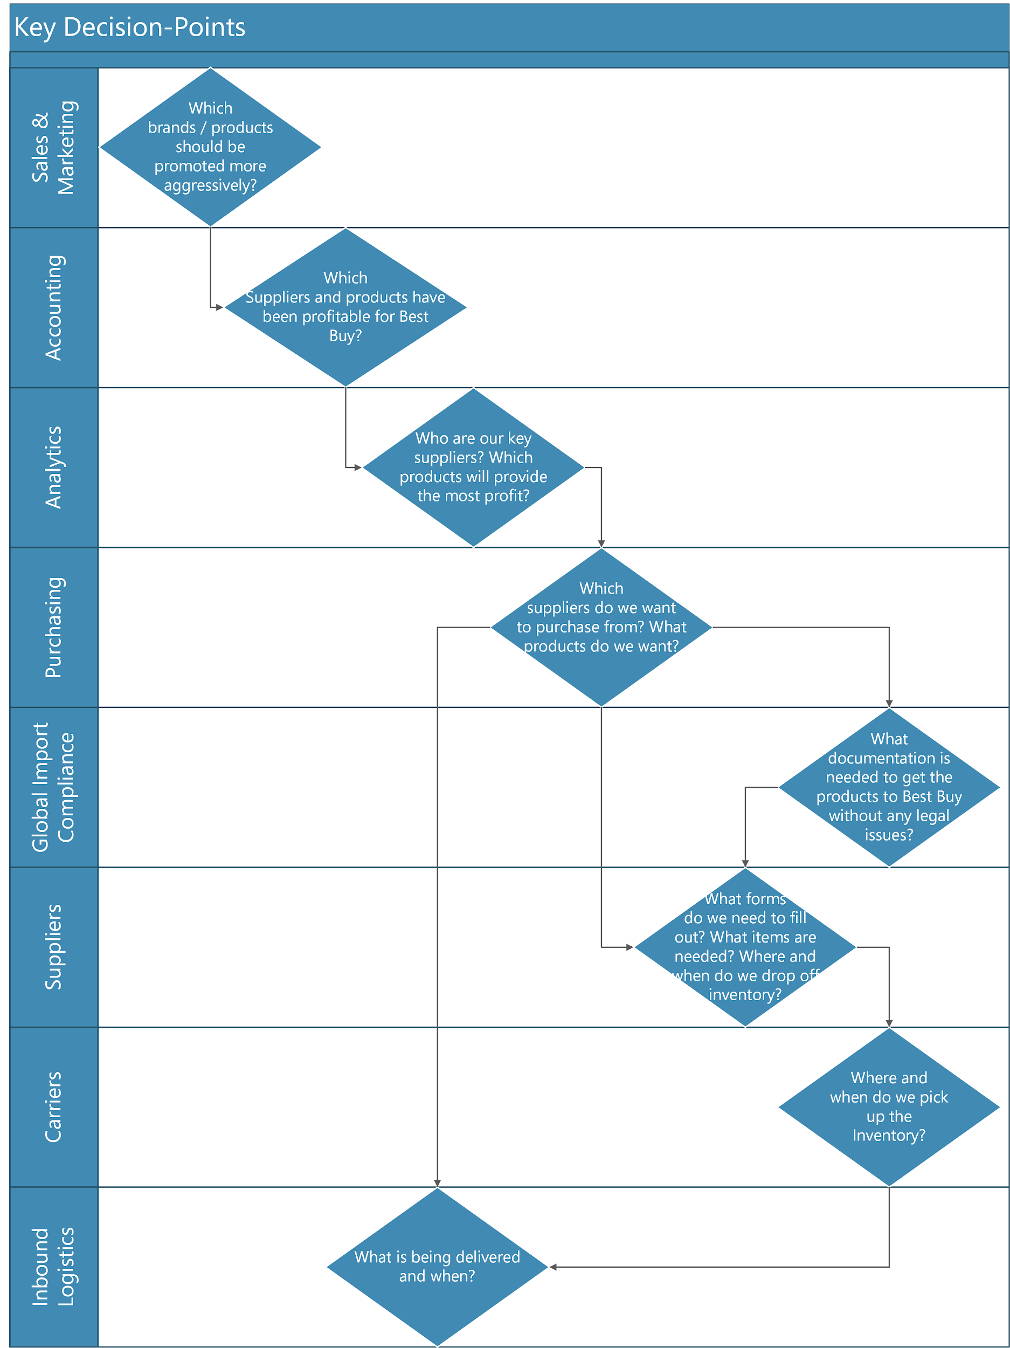

The following information is needed for each of the previously mentioned key decision points:

* Sales & Marketing: Key suppliers and products
* Accounting: Sales figures for each supplier and product line and the costs associated with those sales
* Analytics: Profitable suppliers and products and market trends
* Purchasing: Key suppliers and products, business needs, and inventory levels
* Global Import Compliance: Required documentation for products being imported
* Suppliers: Required documentation forms, purchase orders, and delivery location(s) and time(s)
* Carriers: Pick-up location(s) and time(s), amount of product being shipped, and delivery location(s) and time(s)
* Inbound Logistics: List of products expected for each shipment and expected time of delivery for each shipment

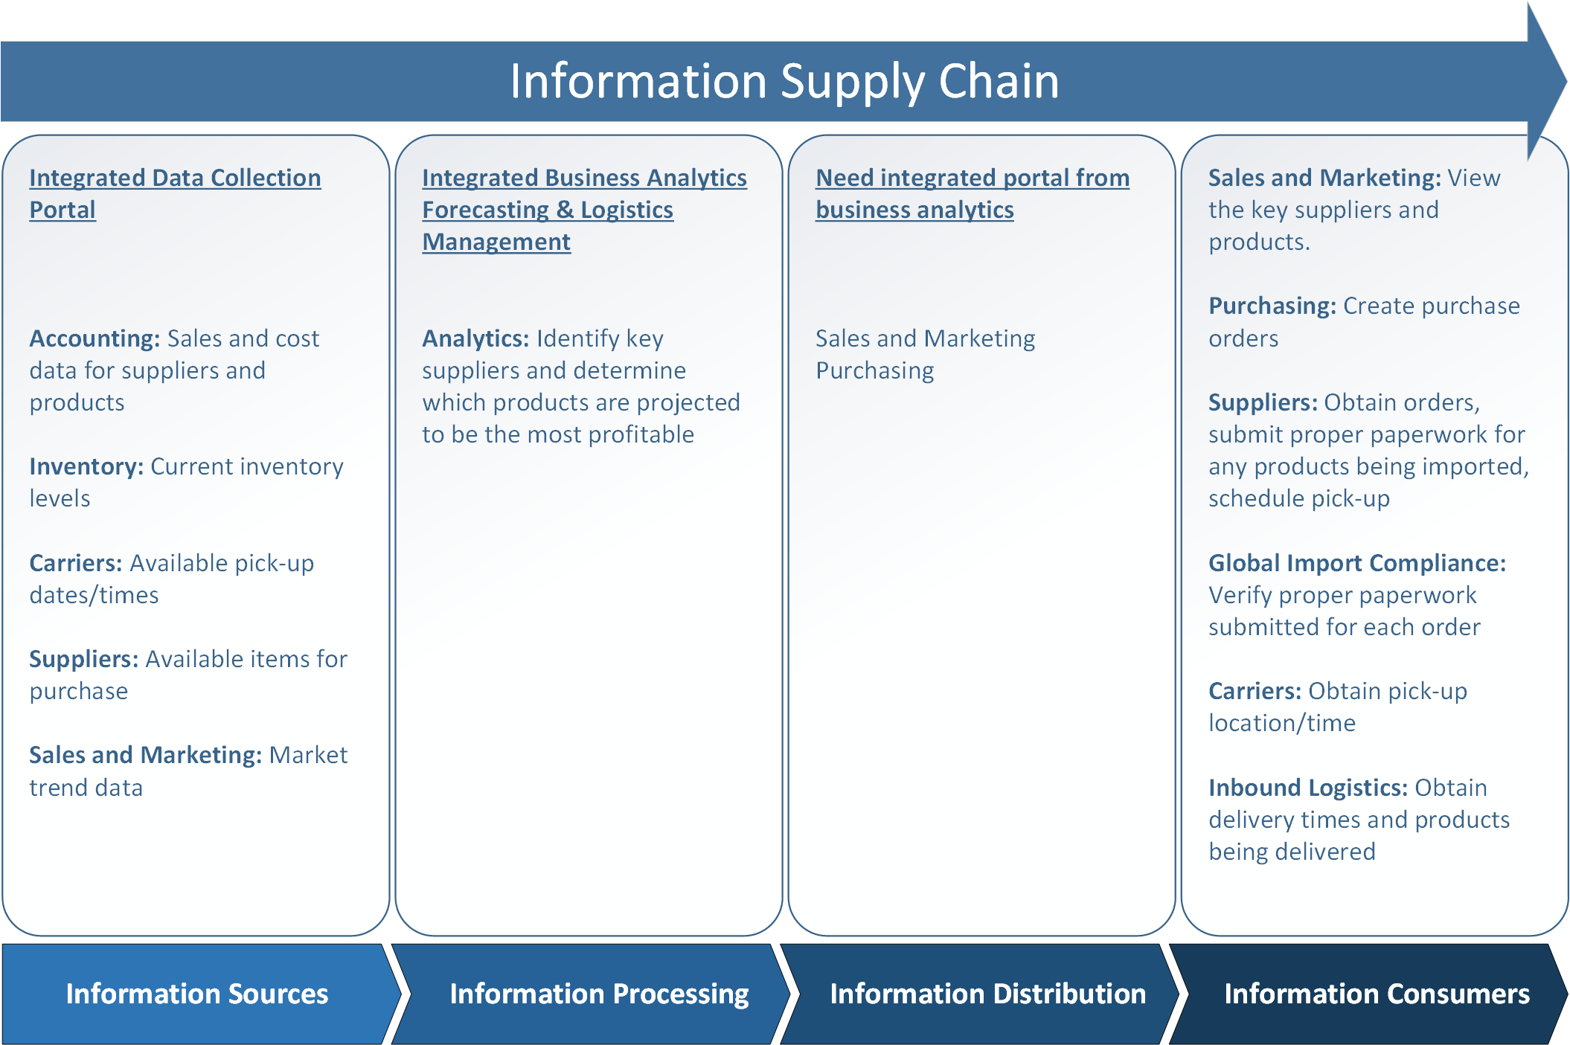

### **1.4 Critical Success Factors and Measures (10%)**

a) What critical success factors or other outcomes

* Improve Best Buy services and inventory turnover as consumers may become more sophisticated online shoppers and purchase products from the manufacturers instead of Best Buy. So Best Buy need better inventory turnover rate.
* Keep high end luxury products such as TVs/home theatre systems in stores. By keeping high end luxury products such as TVs/home theatre systems in the Best Buy stores it can net Best Buy more sales as consumers are able to physically experience the products in store opposed to buying it online.
* Improve the efficiency of its distribution network would another goal for this big company. A communication and distribution network that can efficiently and effectively communicate and transport products from suppliers all over the world.
* Best Buy also needs to develop international markets as much as possible to avoid the negative impact of the slow recovery of the US economy. Because The U.S. economy is slowly recovering. But in 5 to 10 years, it is still in an uncertain position.

b) What business performance measures (KPIs) will you use, to evaluate if your change project has been successful?

First one is Incremental Sales KPI. The Incremental Sales KPI measures the contribution of your marketing efforts to increasing sales revenue. This KPI emphasizes the close relationship between sales and marketing, and how that relationship benefits your organization. Marketing attracts qualified leads, and sales converts those leads into paying customers (which, hopefully, become brand advocates to further fuel marketing efforts).  
A report by Think with Google highlighted that rather than showing how many products your target audience bought, the incremental sales metric shows how many more products they bought because of the particular change in the media spend that you’re testing.

Key Terms:  
Baseline Sales: What you expect to sell for a given time period without marketing.  
Lead: An individual that has expressed interest in your product or service by completing a goal.  
Wins: New customers generated by a marketing campaign.  
Campaign: A marketing communication on a dedicated channel intended for a business' target audience.

The second one is Return on Marketing Investment KPI. The Return on Marketing Investment KPI measures how much revenue a marketing campaign is generating compared to the cost of running that campaign. Effective marketers are driven to connect their time, energy and advertising spend with results that contribute to company growth. This KPI answers the question, “are we recouping the time and money we spent developing and executing our marketing campaigns?”

Key Terms:  
Leads: New prospects generated by a marketing campaign.  
Incremental sales: New revenue generated by a marketing campaign (see "Incremental Sales").  
Wins: New customers generated by a marketing campaign.

The third one is Brand Awareness Metric. The Brand Awareness Metric tracks how your brand is performing on social and on branded search. This metric is designed for a digital marketer looking to capture changes to online brand awareness over time. This metric contains 4 key measures which require additional definition:

For digital marketers tracking brand awareness online, Facebook is the front line for social media campaigns. The number of posts each month helps marketers track the velocity of their social media efforts, while comparing it to the increase in fans over time. These are high level measures which will require further analysis by looking at additional social media metrics.

Similar to Facebook fans, Twitter followers allows digital marketers to track brand visibility on a key social media platform. Tracking this measure over time provides the ability to understand trends in behaviour, especially when paired with total number of posts over time. Consider digging deeper into this measure using more granular social media metrics.

Brand Mentions is unique in that it provides insight into how many times your brand is mentioned online, which includes sources like social media, 3rd party websites, and blogs. To calculate this metric, consider trying out a social listening service such as Talkwalker.

Looking at the number of people who are searching for your brand on search engines provides great insight into the awareness of your brand. In this particular example of the brand awareness metric, the branded search measure is compiled by analyzing how many organic search visits land on a brand’s homepage or product pages.

The last one is First Visit Metric. The First Visit Metric tracks how people are finding your website, such as organic search or social media, and how engaged they are with your website. This metric bases engagement on one of two thresholds: Average Time on Site, and Pages per Visit. Once a threshold has been defined (eg: Average Time on Site greater than 10 seconds) new visitors are categorized as either engaged or not engaged.  
This metric is important as it allows marketers to understand, at a glance, which traffic sources are driving high quality traffic. Using the first visit metric, marketers can explain and dig deeper into sudden spikes in traffic. The total number of new visits represents the amount of new people entering into the funnel on a monthly visit.

### **2.1 Change Project Deliverables, Timeline & Delivery Plan**

According to a research in Supplier Relationship Management (SRM) by Park (2010), an integrative SRM framework is suggested to decompose SRM into individual but collaborative components as shown in the following graph.

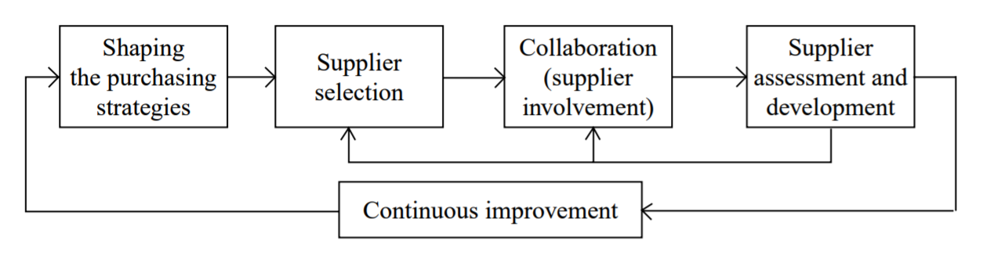

Figure 1 The proposed SRM framework by Park(2010).

For Best Buy, we believe it is effective and efficient to build up an SRM system according to this framework. In order to bring changes to the SRM system incrementally, it is reasonable to decompose the project into smaller sub-projects, bringing changes to each sub-project incrementally with a certain timeline. Based on Park’s SRM framework, we have designed our system application deliverables as below:

1. Integrate intelligence with purchasing strategies. Before selecting suppliers, it is important to identify what products are required and what purchasing strategies will be selected. Purchasing strategies can be classified into two types: (1) competitive approach, assuming buyers can obtain products for the minimum price based on competition between different suppliers; (2) cooperative approach, where the supplier and buyer form a strategic relationship and cooperate to achieve a long-term goal. A good predicting intelligence can effectively help managers to decide what approach to be adopt.

2. Integrate intelligence with supplier selection. A good supplier selection is very important for a company, but its process is complicated. Evaluating criterion could be complex and different due to diversity of products and suppliers. Additionally, managers must decide they should source from either single supplier or multiple suppliers.

3. Integrate communication intelligence with supplier collaboration. A good collaboration between suppliers and buyers are very important in seeking ways to shorten the development time, improve quality, reduce cost, and release new products smoothly.

4. Integrate analysis intelligence with supplier assessment and development. A good assessment tool is very important in rating a supplier’s value by measuring its capability and performance. It can also help selecting a supplier and to segmenting a supplier for differentiated supplier development.

5. Integrate improving intelligence with continuous improvement. Developing SRM should be a continuous work for Best Buy, as the market is always rapidly changing as well as the requirements. Best Buy has to keep its suppliers most updated and optimized, a continuous developing SRM system would be very essential for its future growth.

Based on this framework, we can decompose these deliverables into the four levels of change required for the IT plan:

1. Software development & vendor package delivery;

2. Information services;

3. Integration platforms;

4. IT infrastructure.

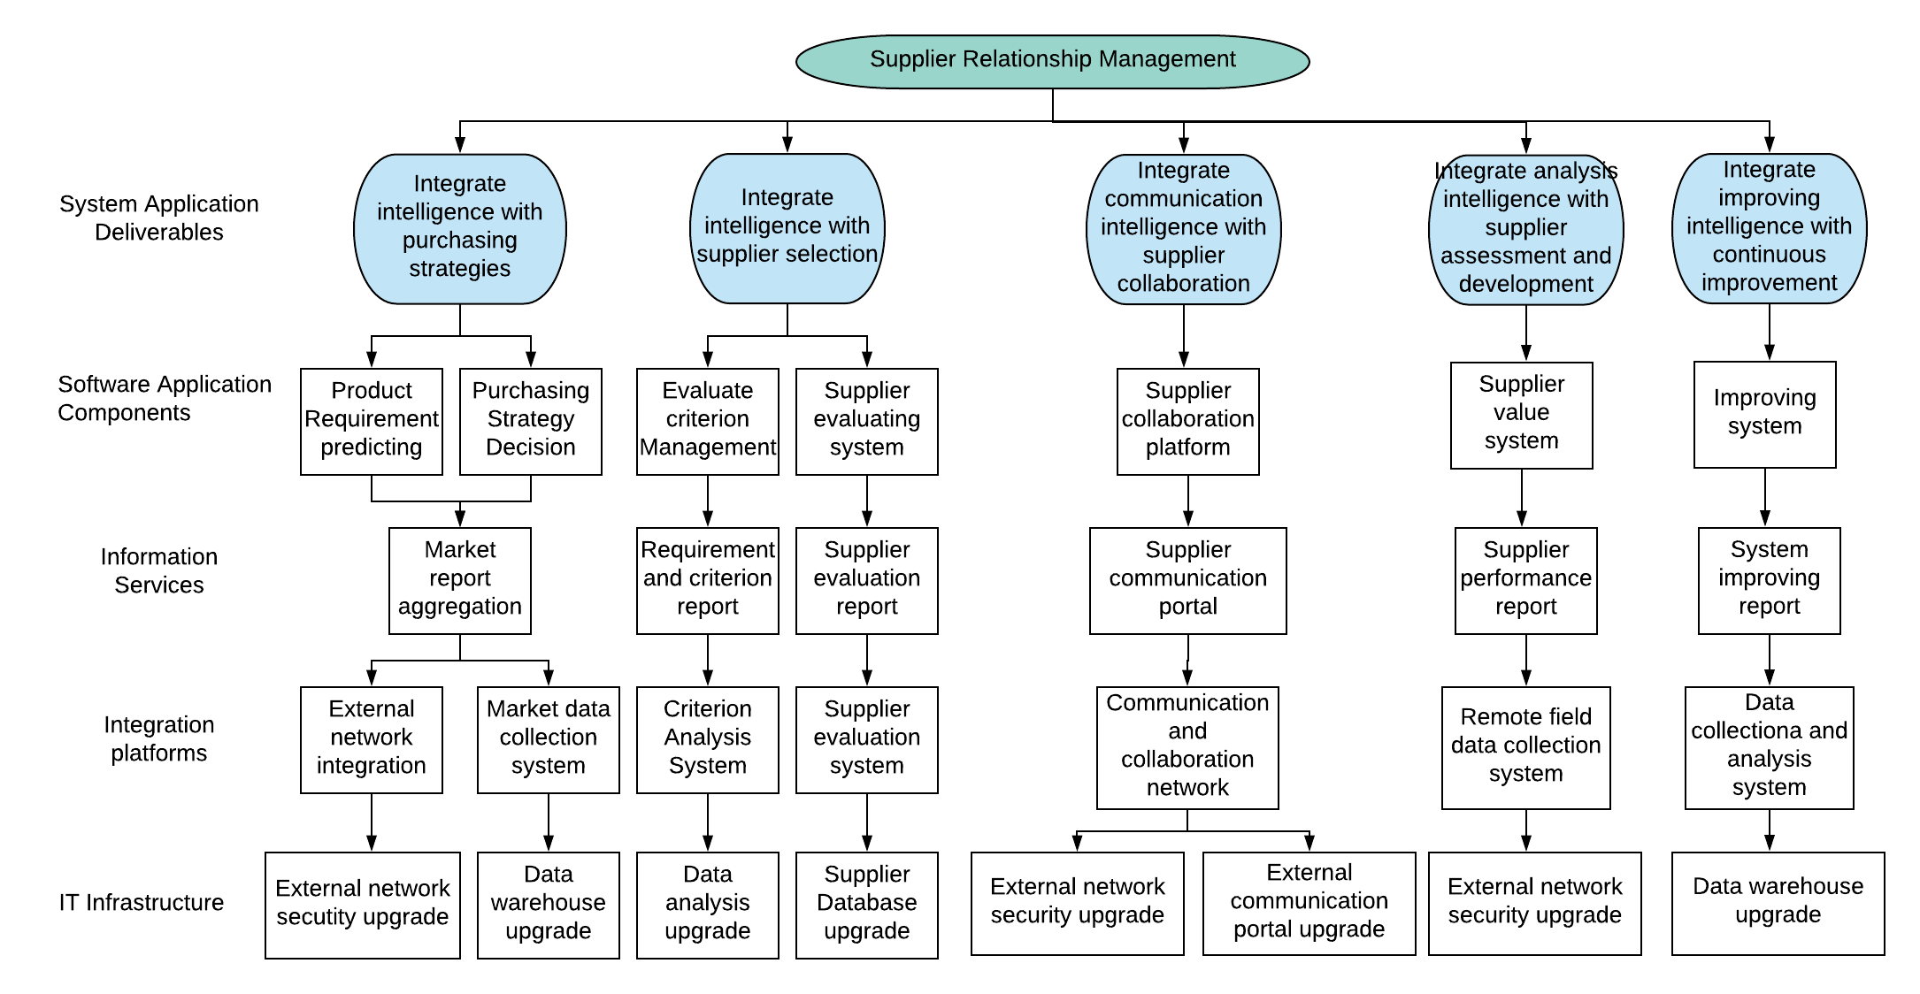

Figure 2 Planning for key deliverables for the SRM changing plan.

With this planning detailed in four levels, we are able to propose a timeline schedule for when technology elements of change will be delivered.

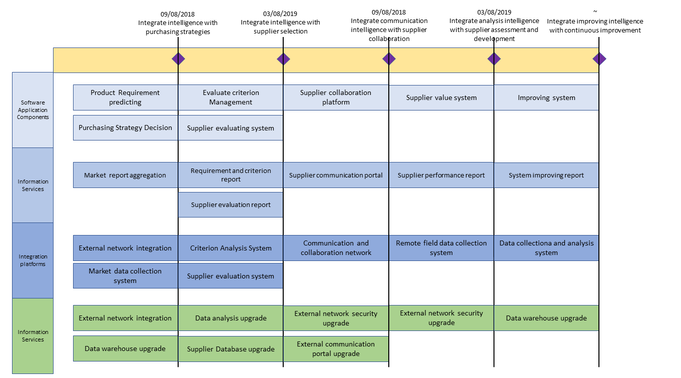

Figure 3 Timeline for key deliverables for the SRM changing plan.

### **2.2 IT Sourcing Plan & Feasibility**

Based on our analysis, we suggest following IT sourcing plan for the main deliverables in our changing plan:

1. Integrate intelligence with purchasing strategies. This will be developed in-house. Since the market and requirement for product is rapidly changing, an in-house system can effectively reduce potential cost in communication and information delivering.

2. Integrate intelligence with supplier selection. An in-house application combined out-sourcing portal will be adopted. Since the suppliers are from various locations, it is difficult to give accurate evaluation solely by Best Buy itself. It is reasonable to collaborate with outsourcing companies for this system.

3. Integrate communication intelligence with supplier collaboration. This system should be developed in-house to make the collaboration between Best Buy and its suppliers fast and responsively and reduce potential cost and damage in communication.

4. Integrate analysis intelligence with supplier assessment and development. This can be outsourced to third-party company for better and specialized assessment.

5. Integrate improving intelligence with continuous improvement. This should be developed with combination of in-house system and out-sourcing portals, as it is important to improve the whole SRM system with the collaboration of all organizations involved in.

Dependencies within these deliverables include:

1. Supplier selection change need purchasing strategies system in place. Data warehouse and external network portal must be implemented first.

2. Supplier assessment and development depends on the information from the supplier selection system, both require the information from a well-implemented supplier evaluation system.

3. The continuous improvement system can only be implemented after all other systems are well implemented. The aim of this system is to improve the performance and value of all other components.

This changing plan is reasonable and valuable to Best Buy, but potential risk still exists. A potential risk is the resistance from suppliers. This changing plan needs the collaboration between Best Buy itself and its suppliers, while some suppliers may refuse to change. A technical feasibility issue is the compatibility between the new SRM of Best Buy and the existing customer relationship management of its suppliers. Since these two systems closely interact with each other within the collaboration of Best Buy and its suppliers, it may cause system failure if these two systems do not work well with each other.

### 

### **3 Summarize the Business Case**

**a) Summarize the analyses in part 1, pulling the case for change together, *briefly* explaining the main strategic, business-process, organizational, and informational changes that will result from implementing this IS application.**

To separate Best Buy from other companies, their main strategic change is to provide unique experiences to their targeted customers. Therefore, their business-process has some changes such as designing their own products to fulfill the preferences of their consumers, utilizing an office system to control routine operations and report any abnormal actions, and utilizing a budgeting system for monitoring return on investment rates that will compare budget and value-added rates of new products. Additionally, by designing their own products to tailor to the customer, market share will increase further. An order processing system is put in place to help Best Buy manage and process all of their orders, simplify the order process for their customers, and the convenience will help promote an increase in customer loyalty. Additionally, Best Buy will have to undergo organizational changes to stay competitive, changes such as creating their own products, collaborating with suppliers to design Best Buy-specialized products, and provide direct marketing and an ecommerce system so that customers have the option to order online or in store and educating employees on how to use the systems that are put in place. Informational changes will include the information used to educate the employees.

**b) Briefly summarize the IT change plan and timeline (part 2), explaining how your application will be delivered in stages, and discussing the main risks and feasibility issues of the change plan.**

The IT change plan will consist of many intelligence integrations and in stages in this sequential order: integrate intelligence with purchasing strategies (in-house), intelligence with supplier selection (outsource), communication intelligence with supplier collaboration (in-house), analysis intelligence with supplier assessment and development (outsource), and improving intelligence with continuous improvement (both in-house and outsource). There are a few main risks such as resistance and refusal to adapt to change from suppliers. A technical feasibility issue exists between Best Buy's SRM and the existing customer relationship management of their suppliers in which, if compatibility issues exist, there may be potential for system failure.

**c) Summarize the implications and impact of the plan for change, then briefly discuss whether you think your company should proceed with this IS Application and why.**

The plan for change will cause Best Buy to undergo strategic, business-process, organizational, and informational changes from implementing the different IS applications that will help set them apart from their competitors. The company should proceed with the IS applications as they will help Best Buy be more efficient through order processing management, more competitive, and it will promote customer loyalty through the simple ordering system and the options to buy in store or through their online ecommerce system. As you can see in part 2, the plan for change is feasible and will provide Best Buy with benefits (summarized in part 3). Therefore, Best Buy should proceed with the IS applications.

# **References**

Phil Wahba (2014, November). A smart home is where the heart is for Best Buy. Retrieved from Fortune:

<http://fortune.com/2014/11/24/best-buy-connected-home/>

Louis Columbus (2016, September). McKinsey Predicts Enterprises Are Adopting Cloud Faster As IT Shifts From Build To Buy. Retrieved from Forbes:

https://www.forbes.com/sites/louiscolumbus/2016/09/17/mckinsey-predicts-enterprises-are-adopting-cloud-faster-as-it-shifts-from-build-to-buy/#3996839e150b

David Linthicum (2016, May). The Benefits of Cloud Computing for the Enterprise. Retrieved from CloudAcademy:

https://cloudacademy.com/blog/the-benefits-of-cloud-computing-for-the-enterprise/

Best Buy. (2018, January). Vendor Direct Import Routing and Shipping Guide [DOC].

[www.extendingthereach.com/wps/portal/!ut/p/b1/04_Sj7QwtjAzN7O0sNSP0I_KSyzLTE8syczPS8wB8aPM4l1dHYMtjbyMDdzdHc0MPA0MXb38zB2NDFwN9HOjHBUBHYSjxA!!/?catalog.contentURL=/nonsecure/na/us/bby/trans/1portlet/trans_log_us_bby.htm](http://www.extendingthereach.com/wps/portal/!ut/p/b1/04_Sj7QwtjAzN7O0sNSP0I_KSyzLTE8syczPS8wB8aPM4l1dHYMtjbyMDdzdHc0MPA0MXb38zB2NDFwN9HOjHBUBHYSjxA!!/?catalog.contentURL=/nonsecure/na/us/bby/trans/1portlet/trans_log_us_bby.htm).

Best Buy Canada. (2018). *Procurement Department* . Retrieved from Best Buy Canada :

<https://www.bestbuy.ca/bestbuycanadacorporate/en/departments-procurement.html>

Haag, E., & DeWolf, V. (2017, November 30). Getting first in line with your key suppliers -

How to become a Customer of Choice | Procurement Transformation Blog. Retrieved

from:

[https://www.capgemini.com/consulting/2016/02/getting-first-in-line-with-your-key-](https://www.capgemini.com/consulting/2016/02/getting-first-in-line-with-your-key-suppliers/)

[suppliers/](https://www.capgemini.com/consulting/2016/02/getting-first-in-line-with-your-key-suppliers/)

Hogan, D. (2017, July 12). *What is Supplier Relationship Management (SRM)?* Retrieved

from Liaison :

<https://www.liaison.com/blog/2017/07/12/supplier-relationship-management-srm/>

IBM. (2005). *Enhance the Value of your Supplier Relationships.* Retrieved from IBM:

<https://www-935.ibm.com/services/us/gbs/bus/pdf/g510-3857-enhance-the-value-of-y>

[our-supplier-relationships-world-class-services-from-ibm-leading-software-from-sap.pdf](https://www-935.ibm.com/services/us/gbs/bus/pdf/g510-3857-enhance-the-value-of-y)

Lim, M. (2018). *What is the Difference Between Procurement and Purchasing?* Retrieved

from Procurify:

<https://blog.procurify.com/2014/02/07/what-is-the-difference-between-procurement-a>

[nd-purchasing/](https://blog.procurify.com/2014/02/07/what-is-the-difference-between-procurement-a)

PwC Accountants. (2013). *Supplier Relationship Management.* Retrieved from

PricewaterhouseCoopers NL: <https://www.pwc.nl/nl/assets/documents/pwc-supplier-relationship-management.pdf>

Spiegel, R. (2011, January 28). *SRM Leaders Outpace Peers On Lead Times, Other Key Metrics*. Retrieved from Logistics Management :

<https://www.logisticsmgmt.com/article/srm_leaders_outpace_peers_on_lead_times_other_key_metrics>

Webb, J. (2017, February 21). *What Is Supplier Relationship Management?* Retrieved from

Forbes:<https://www.forbes.com/sites/jwebb/2017/02/21/what-is-supplier-relationship-management/>

Park, J., Shin, K., Tai-Woo, C., & Park, J. (2010). An integrative framework for supplier relationship management. Industrial Management & Data Systems, 110(4), 495-515.